Shaker for Microplates—MS300
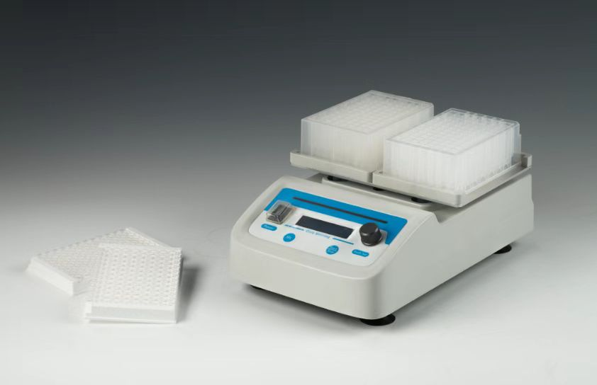
Description:
MS300 Shaker for Microplates is a high speed shaker with direct brushless DC motor and microprocessor controlled technique, specifically for elisa plate and cell culture plate. It can hold 2pcs elisa plates(96/384wells), deep-well plates and cell culture plates(24/48/96wells).

Features:
- LCD real-time display system status and parameters.
- Timer from 0 to 99h59min.
- Support 2 standard microplates and deep well plates.
- Brushless DC motor, low noise, small interference, free maintenance.
- The built-in status indicator allows the user to quickly get the status of the device.
- When timing ends, system will make an alarm voice automatically.
- Automatic fault detection and buzzer alarm function.
- With special fixing way, install and disassemble the plates quickly, don’t need the additional tool.

Parameters:
Type  Parameter | MS300
Time range | 1min ~ 99h59min/∞
Speed range | 200～2000rpm
Mixing orbit | 3mm
Speed step value | 10rpm
With status indicator light | Yes
Sample capacity | 2plates
Power | 45W
Voltage | DC24V/2A
Dimension(mm) | 294×200×107
Weight(kg) | 3.8

